Bad Voltage Reference

Introduction

Voltage reference circuits are used to compare voltages with the use of comparators or differential amplifiers. Applications include ECG (electrocardiogram) and EEG (electroencephalogram) amplifiers.

Thus the output of a voltage reference is usually connected to the input of an operational amplifier, comparator or differential amplifier.

This article is about a bad (not wrong) voltage reference circuit and possible improvements to this circuit.

We must not forget that there are complete voltage reference integrated circuits sold on the internet, thus making all possible solutions to the voltage reference problem irrelevant.

Bad Voltage Reference

You can make the following voltage reference with resistors and capacitors:

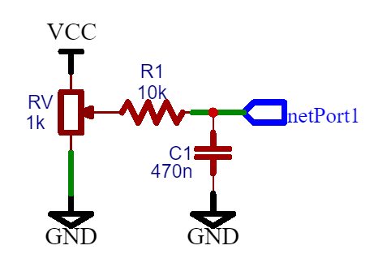
Figure 1: Bad Voltage Reference

The problem with this circuit is that most differential amplifiers try to match the voltages of both inputs. The input connected to the first pin of the differential amplifier will eventually drag the voltage reference output voltage up or down, thus influencing the voltage reference value no matter how big is the value of the C1 capacitor, although increasing the C1 value will reduce the magnitude of this problem.

At maximum Rv setting, the output resistance is equal to (assuming the power supply is a current source):

Ro = R1 + Rv
(Where: R1 = 10 kohm, Rv = 1 kohm)

2. Zener Diode Voltage Reference

A diode voltage reference or zener diode voltage reference is an improvement to resistor and capacitor voltage reference:

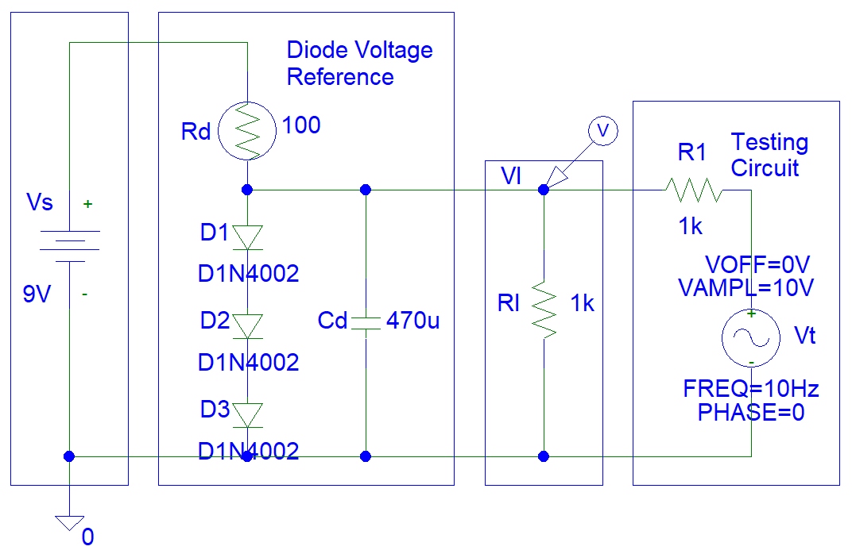
Figure 2: Diode Voltage Reference Circuit

This circuit is probably the best solution to the voltage reference problem. It is low cost and the most effective.

Simulations show how effective the diode voltage reference circuit is:

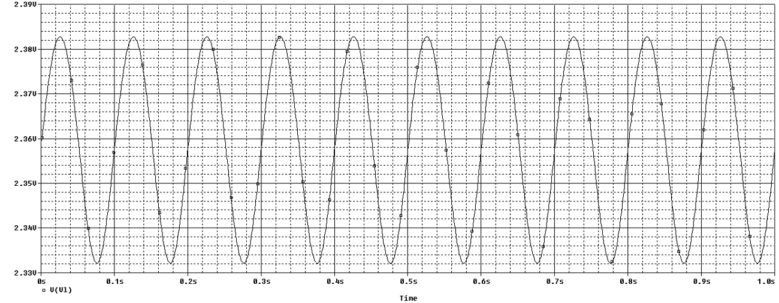
Figure 3: Diode Voltage Reference Simulations

You can also improve the circuit by connecting the output of the zener diode voltage reference to an operational amplifier input.

3. Op-Amp Voltage Reference

The schematic shown is a good op-amp voltage reference:

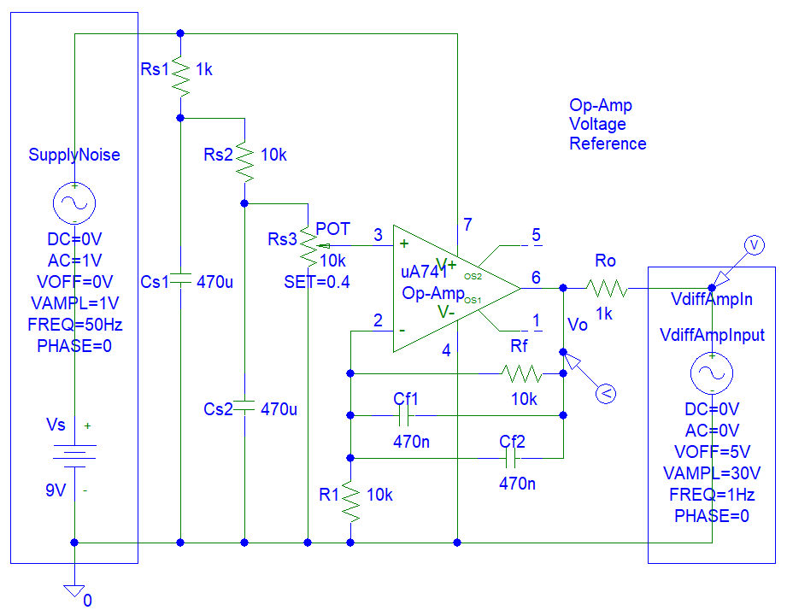
Figure 4: Op-Amp Voltage Reference

Output Voltage equals to:

Vo = Ao * (Vi3 - Vi2)
= Ao * (Vi3 - Vo * R1 / (R1 + Rf))
Vo * (1 + Ao * R1 / (R1 + Rf)) = Ao * Vi3
Vo * Ao * R1 / (R1 + Rf) = Ao * Vi3
Vo * R1 / (R1 + Rf) = Vi3
Vo = Vi3 * (Rf + R1) / R1
Vo = Vi3 * (10 kohms / 10 kohm + 1)
Vo = 2 * Vi3

Simulations show a very small variation in op-amp output (100 uV ) for 30 V variation in differential amplifier input.

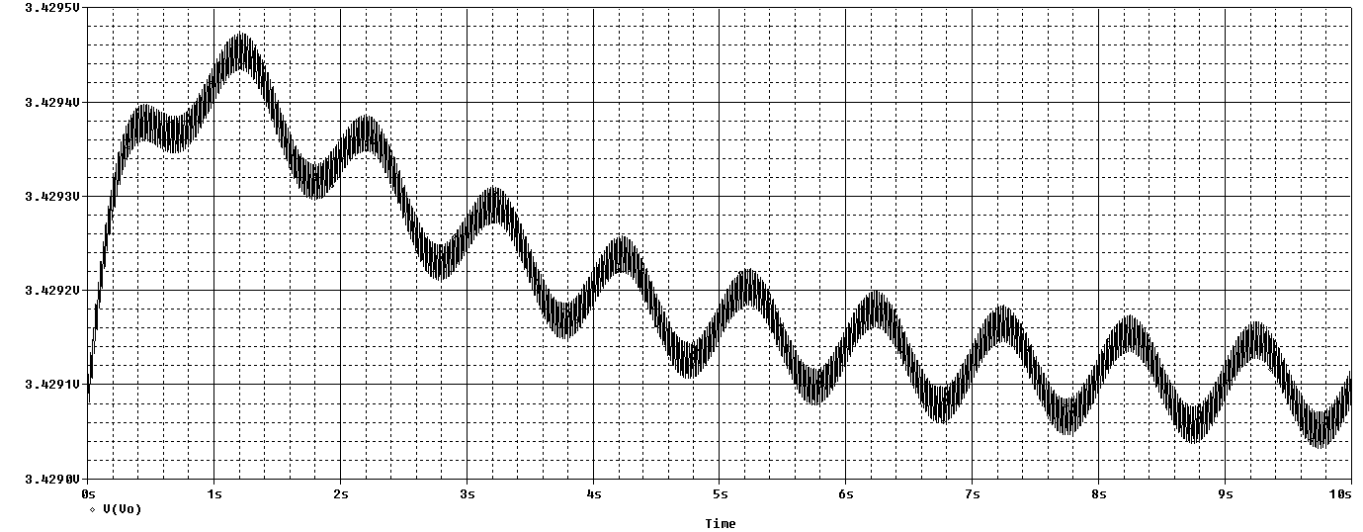
Figure 5: Op-Amp Voltage Reference Simulations

The frequency is 1 Hz. Thus the period is 1 second.

4. Voltage Regulator Voltage Reference

Voltage regulators circuits do not require the use of soldering iron wire wrap tools because most of those ICs (integrated circuits) only have three pins. An operational amplifier IC needs a minimum of 6 pins (two for inputs, two for power supply and one for output = 5, there are no 5 pin ICs packages, there are 6 pin opto-coupler ICs).

This is a negative voltage reference circuit:

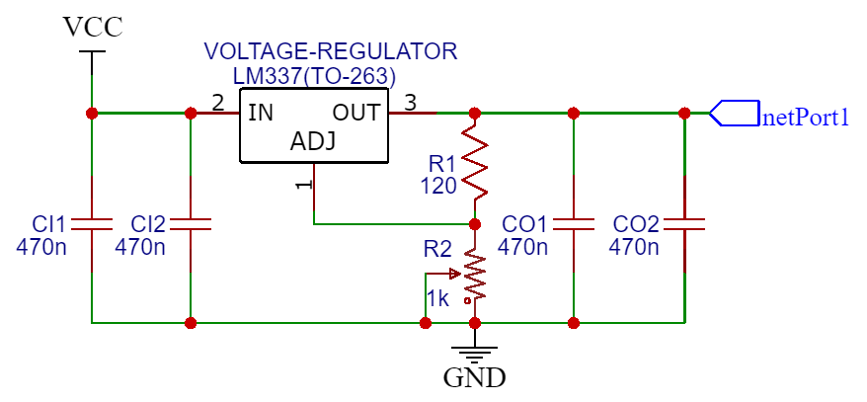
Figure 6: Voltage Regulator Voltage Reference

The output is equal to (refer to Texas Instruments specifications):

R2 = R1 * (Vo/-1.25 - 1)
R2 = -R1*Vo/1.25 - R1
-R1*Vo/1.25 = R2 + R1
Vo = -1.25*(R2 + R1) / R1
Vo = -1.25*R2/R1 - 1.25

Thus the output will be from -1.25 V to -37 V. There are positive voltage regulators (eg. LM317). Similar circuit and voltage output calculations can be implemented for this IC (LM317).

5. Other Transistor Voltage Follower Circuits

You can also try a transistor voltage follower.

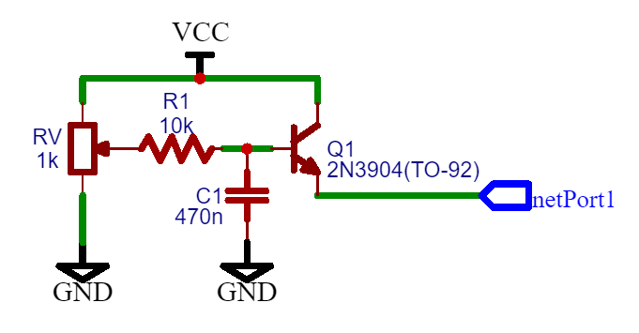
Figure 7: Improved Voltage Reference 1

At maximum Rv setting, the output resistance is equal to:

Ro = (Beta*re + R1 + Rv) / (Beta + 1)
Where: Beta = Transistor Current Gain,
re = 26 mV / Ie (emitter current),
R1 = 10 kohm, Rv = 1 kohm, C1 = 470 nF)

The output resistance will be a lot smaller than the output resistance of the circuit in Figure 1.

The transistor circuit shown has many issues. The first problem is that the circuit does not work for reference voltage output being pulled up by the differential amplifier, thus turning OFF the transistor and thus making the voltage reference output irrelevant. Thus the transistor voltage follower circuits are only half as good as the best solution (the operational amplifier voltage reference).

The improved circuit is more versatile:

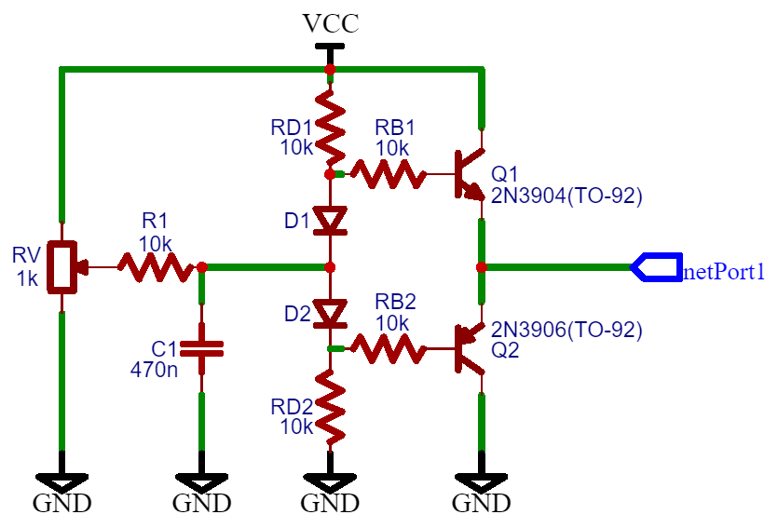
Figure 8: Improved Voltage Reference 2

Yet there is still a problem with output resistance being too high. Thus I replaced the a signal transistor with Darlington pair:

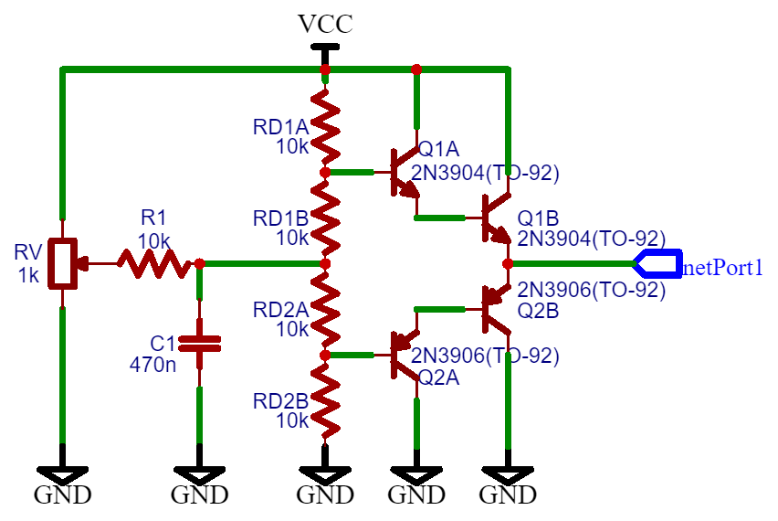
Figure 9: Improved Voltage Reference 3

6. Conclusion

I conclude this article by stating how bad is the resistor voltage reference, how transistor voltage reference circuits are only slightly better (than the resistor/capacitor circuit) and why you should only use standard integrated circuits (ICs), operational amplifiers or voltage regulators for voltage reference circuits only.

